

Practices for Secure Software Report

Table of Contents
Practices for Secure Software Report 1
Document Revision History 3
Client 3
Developer 4
1. Algorithm Cipher 4
Hash Functions: 4
Random Numbers 4
Symmetrical vs Asymmetrical Encryption 4
History and Modern State of Ciphers 5
2. Certificate Generation 6
3. Deploy Cipher 6
4. Secure Communications 6
5. Secondary Testing 6
6. Functional Testing 7
7. Summary 8
API 8
Cryptography 8
Client/Server 9
Error Handling 9
Code Quality 9
8. Industry Standard Best Practices 9

Document Revision History

Version | Date | Author | Comments
1.0 | 10/13/2026 | Christopher Daisy | Security Overview

Client



Developer
Christopher Daisy

Algorithm Cipher

To meet the security criteria for the Artemis Financial project, we can implement many kinds of security techniques: Encryption, HTTPS, Hashing, and random numbers. For this project, we can use Certificate Authority for data in transit, SHA-256 for checksum verification, and AES encryption for data at rest.

Hash Functions:
Hash functions are a method of converting data into fixed-size string of characters. The purpose of this hashing function is to ensure that data has not been tampered with. Referred to as a ‘Checksum’, the input data is first hashed, then after the data reaches its destination, the ‘checksum’ is then compared with the original hash. If both hashes are the same, then the data is confirmed to be the same. Otherwise, should it differ, then something has happened that has altered the data, and it should be rejected or replaced.
Hashing is a one-way function that cannot be reversed. In this way, data is not exposed to outsiders and cannot be reconstructed from having only the output data.
Using SHA-256 is widely used hashing function that is collision-resistance, which means that chances of two different input data resulting in the exact same output are technically possible, but finding one is computationally infeasible and astronomically rare. As of today, SHA-256 has no critical vulnerabilities.

Random Numbers
By using random numbers, we can introduce “Entropy” into the system. Entropy is the measurement of uncertainty or disorder in a system. By artificially creating disorder into the environment, it minimizes the chances of outside users cracking or detecting patterns. The best measure is to source the random seed with an attribute that is contained solely within the source database. Through this, an outsider trying to infiltrate will have a difficult time detecting patterns, minimizing their chances of deciphering data.

Symmetric vs Asymmetric Encryption
Both encryption methods, Symmetric and Asymmetric, achieve the same outcome: converting messages into ciphertext that is unreadable without the key, with the goal of preventing outsiders from interpreting the message. Each procedure does reach those goals in a different manner, with each having specific advantages and shortcomings.
Symmetric Encryption uses one key for both encrypting and decrypting the data. From this method, the conversion is relatively quick and efficient. The downside of this method is that if a key is compromised, then all the data that was encrypted by that key will now be vulnerable. As of today, AES is the current standard for encrypting data.
Asymmetric Encryption uses a pair of keys, a public and private key, to encrypt and decipher the same data. The pair of keys is generated by the server; the private key is kept by the server, and the public key is given to the client. The client can use the public key to encrypt their data, send it to the server, and is then deciphered by the private key. This setup prevents onlookers who intercept the data from reading or deciphering the message. In combination with Certificate Authorities (CA), which are third party organizations that verify key pairs with their domains, this establishes an extra layer of trust for clients using their website. The downside of this setup is that creating the pair of keys requires more computation compared to symmetric encryption, which can become an issue when speed is a priority. HTTPS and RSA use asymmetric encryption.

History and Modern State of Ciphers
Ciphers have been commonly used for over a millennium, with the earliest records dating back to ancient Egyptian times. Egyptians would use Hieroglyphic Encryption to secretly communicate with each other. During the Romans, there was one popularized cipher that was used known as the “Caesar Cipher”. You would take the original message and then shift every letter forward three steps, disguising the message into ciphertext that no one without the code can read. During World War 1, the Germans famously used the Enigma Machine to disguise their messages from the Allied forces. When the code was successfully crack, the power balance shifted heavily against the Germans. Also, a famous encoding method that was use was with the “Code Talkers”, where western forces used Native American languages, including Navajo, to disguise their commands. The Axis force had absolutely no way to crack the code since they had no familiarity with their language. It was a major success.
In 1970, there was a pressing demand in the computing world for data security. The NBS (National Bureau of Standards) tasked IBM to develop a cipher, known as “Lucifer”. In 1977, it was formally accepted as a standard and formally changed the name to DES (Data Encryption Standard). This encryption method work well till around 1996 when DES was eventually cracked. Around 1997, once again the National Institute of Standards and Technology (NIST) (Which replaced the NBS) issued an open call for any organization to replace the now deprecated encryption algorithm. Two Belgium cryptographers, Dr. Joan Daemen of Proton World International and Dr. Vincent Rijmen, a postdoctoral researcher in the Electrical Engineering Department (ESAT) of Katholieke Universiteit Leuven, developed a new cipher known as “Rijndael” cipher and uses a symmetric key algorithm. Between 15 different candidates, this cipher was declared the winner of the contest, then was recognized as Advanced Encryption Standard (AES) and was formally published as FIPS 197 in November 2001. As of now AES is the current standard used for modern encryption.
In the future, the pressing issue that challenges encryption is the advancement of quantum computing. What makes modern encryption so powerful is that cracking a cipher through brute force would take an astronomically long time, even with the most powerful computers today. Quantum computing has the possibility of exceeding today’s computers which could trivialize modern encryption methods. There are currently quantum safe encryption methods in development when the time comes. Another challenge for encryption today is the accelerating pace of AI being used. AI can take massive amounts of data and can be used to test security vulnerabilities.

Certificate Generation
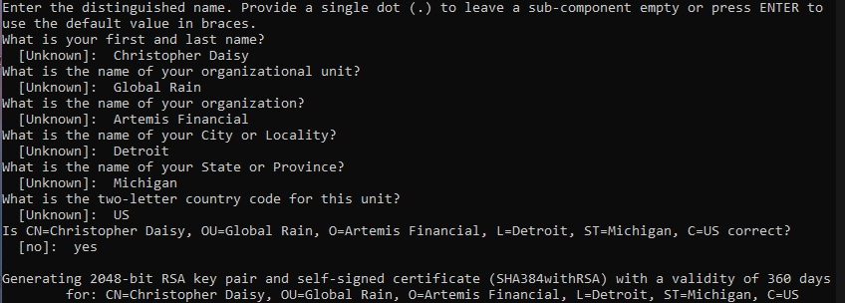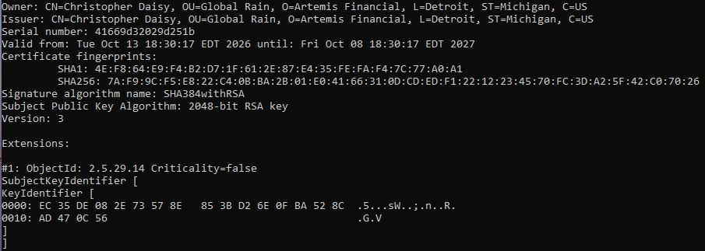
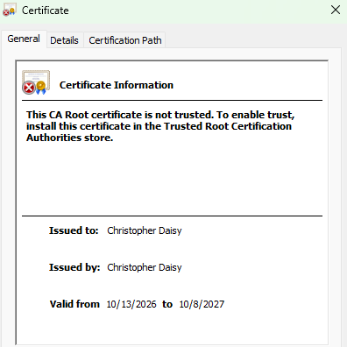

Deploy Cipher
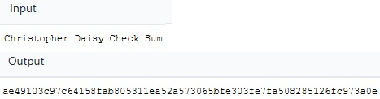

Secure Communications
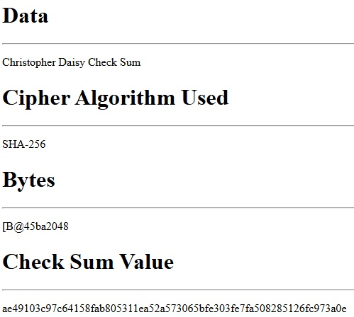

Secondary Testing
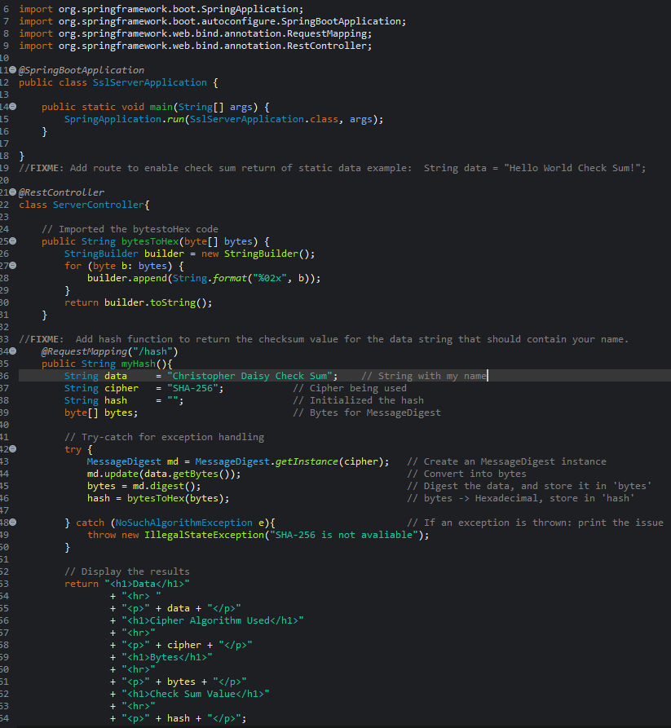
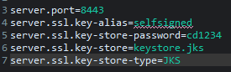

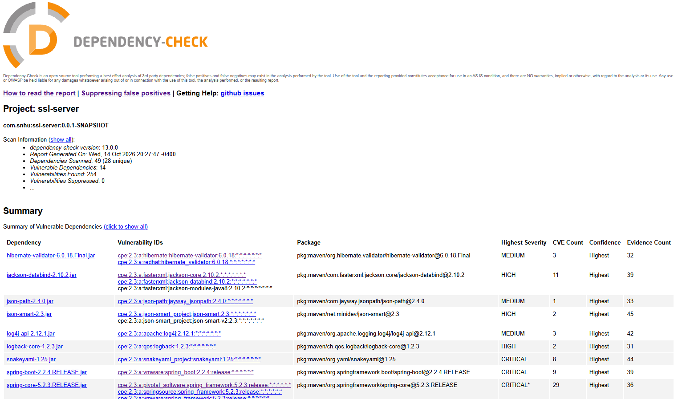

Functional Testing

Summary

API
We are using spring boot as a RESTful API, so we’ll need to confirm that each functionality is set according to best practices and secure coding standards, like parameterized queries, and keeping sensitive information out of the requests.

Cryptography
Using encryption methods to secure data in multiple layers: TLS/HTTPS with Certificate Authorities (CA), SHA-256 for checksum verification, and AES can be applied for data at rest.

Client/Server
With API usage, it must imply client/server interaction. Proper use of Authentication, Authorization should be enforced.

Error Handling
Some of the code requires error handling methods to properly work, specifically “MessageDigest”. Proper use of error handling will ensure that the code will have contingency plans should any error occur and prevent a full system crash.

Code Quality
Through proper usage of HTML code, functions and efficient algorithms, we can make the site effective and HTML/CSS code manipulation can make the site look visually appealing.

Industry Standard Best Practices
With all the sensitive data that Artemis Financial will be interacting will, it is imperative that all security methods should be implemented. We can achieve all these goals with checksum verification through using SHA-256, using parameterized queries to prevent SQL injection vulnerabilities, using SAST testing with the help of OWASP to report vulnerabilities with the libraries and dependencies, and using encryption methods, like AES for data at rest, and the usage of HTTPS/TLS for data in transit. Using Certificate Authorities (CA) would add an additional layer of trust by having a verified third party to establish user security when accessing the business’s server.
The modern world embraces the convenience of the internet for their businesses. When using sensitive data, especially in the financial sector, attackers will use any exploit possible to intervene, forge, blackmail, and whatever measure possible to access that data. The risk and consequence of security breaches or leaks can cause massive disruption, both the business and the clients that use the service. The penalties not only hurt the company’s image and trust, but they can also have legal and financial fees included which would spell disaster. By using encryption methods, limiting access, using permissions, authentication and authorization methods, we can deter attackers with so many measures that brute force is not a viable option. While all these methods can create an effective barrier for data, there is always the human element that can bypass all those safeguards: phishing, peering eyes, or poor security protocol can cause leaks to occur. By saying this, it’s important to understand that no security system will ever be 100% secure. The security field is always evolving at the same pace as the criminals figuring out clever ways to bypass them.

